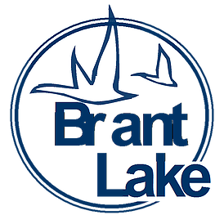
Brant Lake Improvement Association
2020 Annual Meeting
When: Saturday June 6th, 9AM
Where: Meeting will be held via ZOOM
ZOOM ID visit us at our website: www.brant-lake.com or
Facebook: Brant Lake Improvement Association
Agenda Topics:
Voting New Officers and New Board Members: President, Vice President, Treasure, Secretary
Speakers:
GP&P presentation – General updates and Spillway update - Q&A available during presentation
Lake County Zoning Q&A - No presentation - Questions to be submitted prior to meeting and read at the meeting as contact is unable attend meeting. All questions will be compiled and submitted at once anonymously to Lake Counting Zoning contact.
Please submit any/all question to the BLIA Secretary with SUBJECT LINE “Zoning Question” to jody.heberlee@gmail.com by 7pm May 28th. Again all submissions will remain anonymous, with questions and answers to be read at the annual meeting.
State of the BLIA
Directory
Financials
** SPECIAL NOTE: To keep our members safe, there will be no Pancake Feed this year due to COVID-19.

